AGV Presentation Document

Updated at: 18/5/2023

Contents

1. General solution 3

1.1. Requirements 3

1.2. Solution 3

2. AGV basic explanations 4

2.1. AGV definition 4

2.2. Types of AGV 5

3. Technologies 7

3.1. Hardware 7

3.1.1. General configuration 7

3.1.2. RFID 9

3.1.3. Bluetooth Low Energy 10

3.1.4. Laser distance sensor 14

3.2. Software 16

3.2.1. User Interface for Operator 16

3.2.2. User Interface for Manager/Admin/Developer 16

4. Operations explanation 16

4.1. Localizing method 16

4.2. Mapping method 18

4.3. Guiding method 20

4.4. Manual mode 23

4.5. Automated mode 23

# **1. General solution**

## **1.1. Requirements**

A robot that helps transport packages from warehouse to production lines and vice versa.

## **1.2. Solution**

Building Automated Guided Vehicle (AGV) that has manual and automated operating modes to conduct package transporting requests from operators and managers.

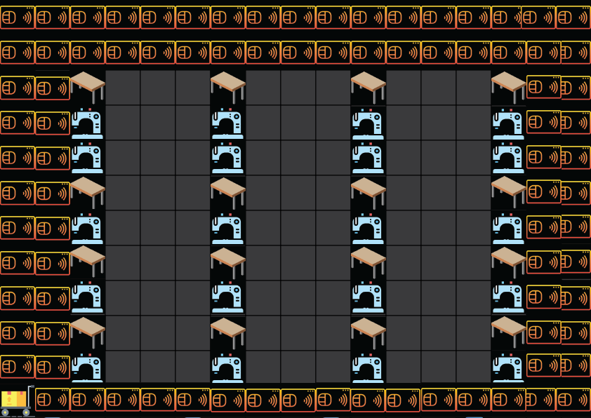**Solution 1: Using only RFID cards which sticked on the floor for navigation system and laser sensors for approximate distance measure**

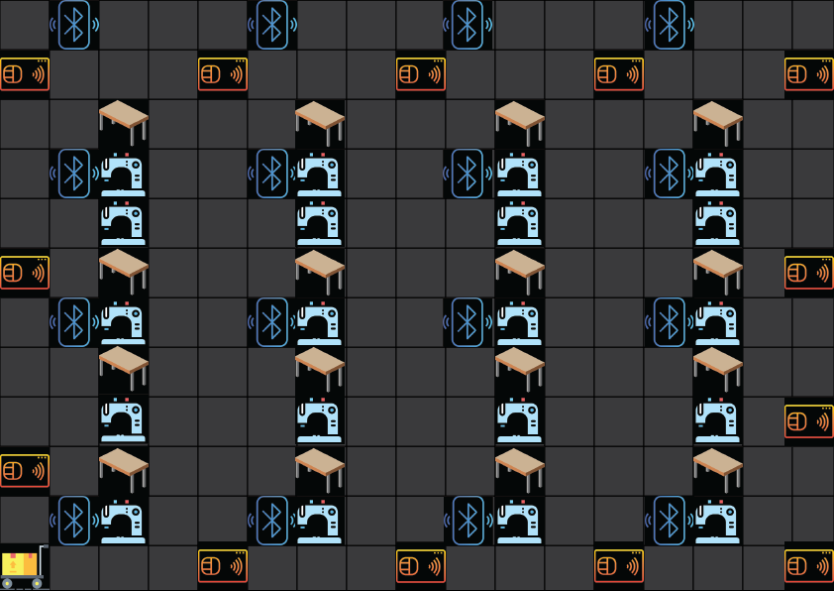**Solution 2: Using RFID cards which sticked on the floor and Bluetooth Low Energy (BLE) stations (beacons) for navigation system and laser sensors for approximate distance measure**

# **2. AGV basic explanations**

## **2.1. AGV definition**

An automated guided vehicle (AGV), is a portable [robot](https://en.wikipedia.org/wiki/Robot) that follows along marked long lines or wires on the floor, or uses radio waves, vision cameras, magnets, or lasers for navigation. They are most often used in industrial applications to transport heavy materials around a large industrial building, such as a factory or warehouse. Application of the automatic guided vehicle broadened during the late 20th century.

## **2.2. Types of AGV**

*Towing Vehicles* (also called "tugger" vehicles) were the first type introduced and are still a very popular type today. Towing vehicles can pull a multitude of trailer types and have capacities ranging from 2,000 pounds to 160,000 pounds.

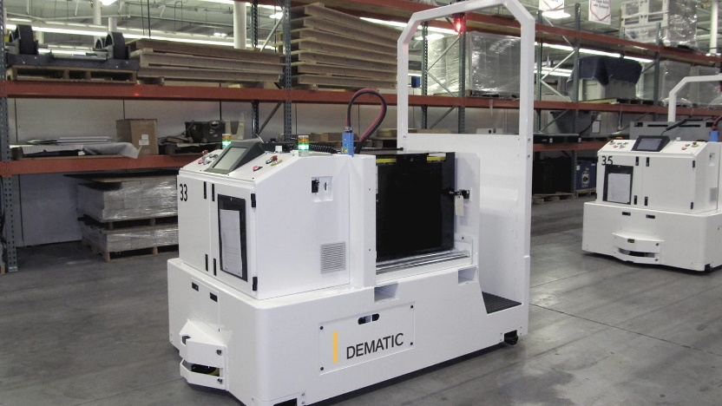

*AGVS Unit Load Vehicles* are equipped with decks, which permit unit load transportation and often automatic load transfer. The decks can either be lift and lower type, powered or non-powered roller, chain or belt decks or custom decks with multiple compartments.

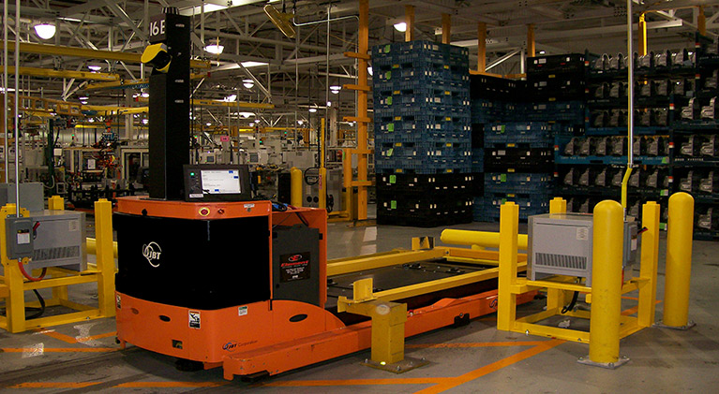

*AGVS Pallet Trucks* are designed to transport palletized loads to and from floor level; eliminating the need for fixed load stands.

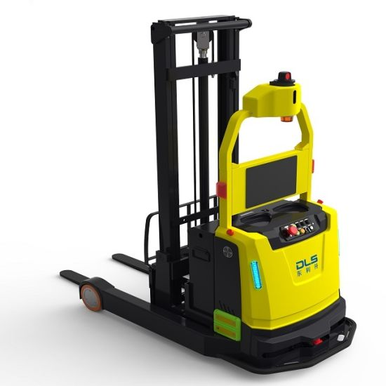

*Light Load AGVS* are vehicles which have capacities in the neighborhood of 500 pounds or less and are used to transport small parts, baskets, or other light loads though a light manufacturing environment. They are designed to operate in areas with limited space.

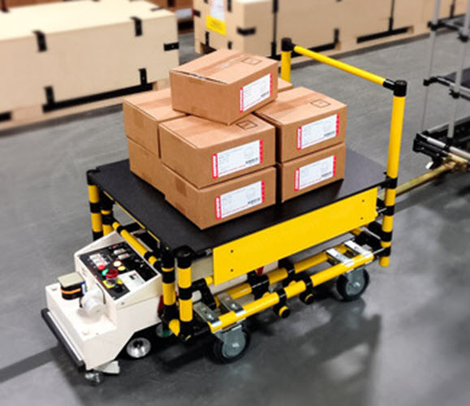

*AGVS Assembly Line Vehicles* are an adaptation of the light load AGVS for applications involving serial assembly processes.

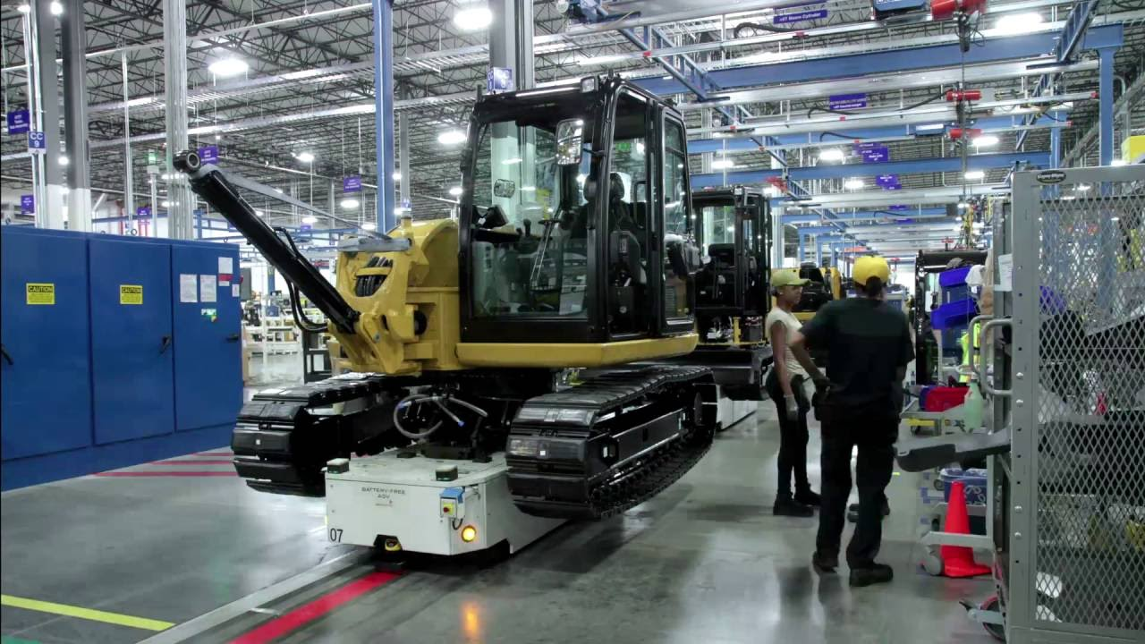

# **3. Technologies**

## **3.1. Hardware**

### **3.1.1. General configuration**

General hardware configuration on AGV is described as below:

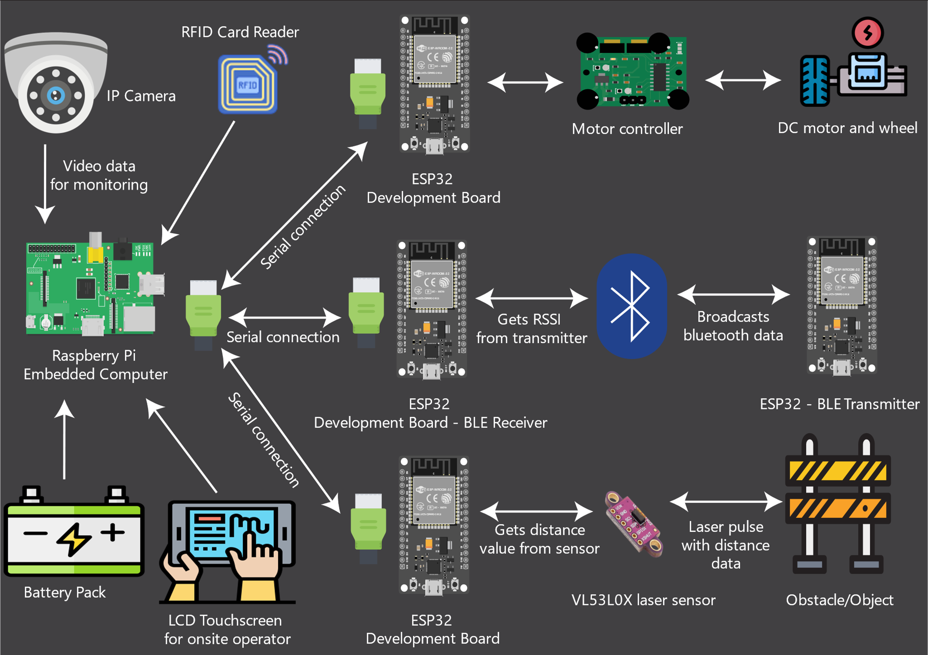

*Hardware used*

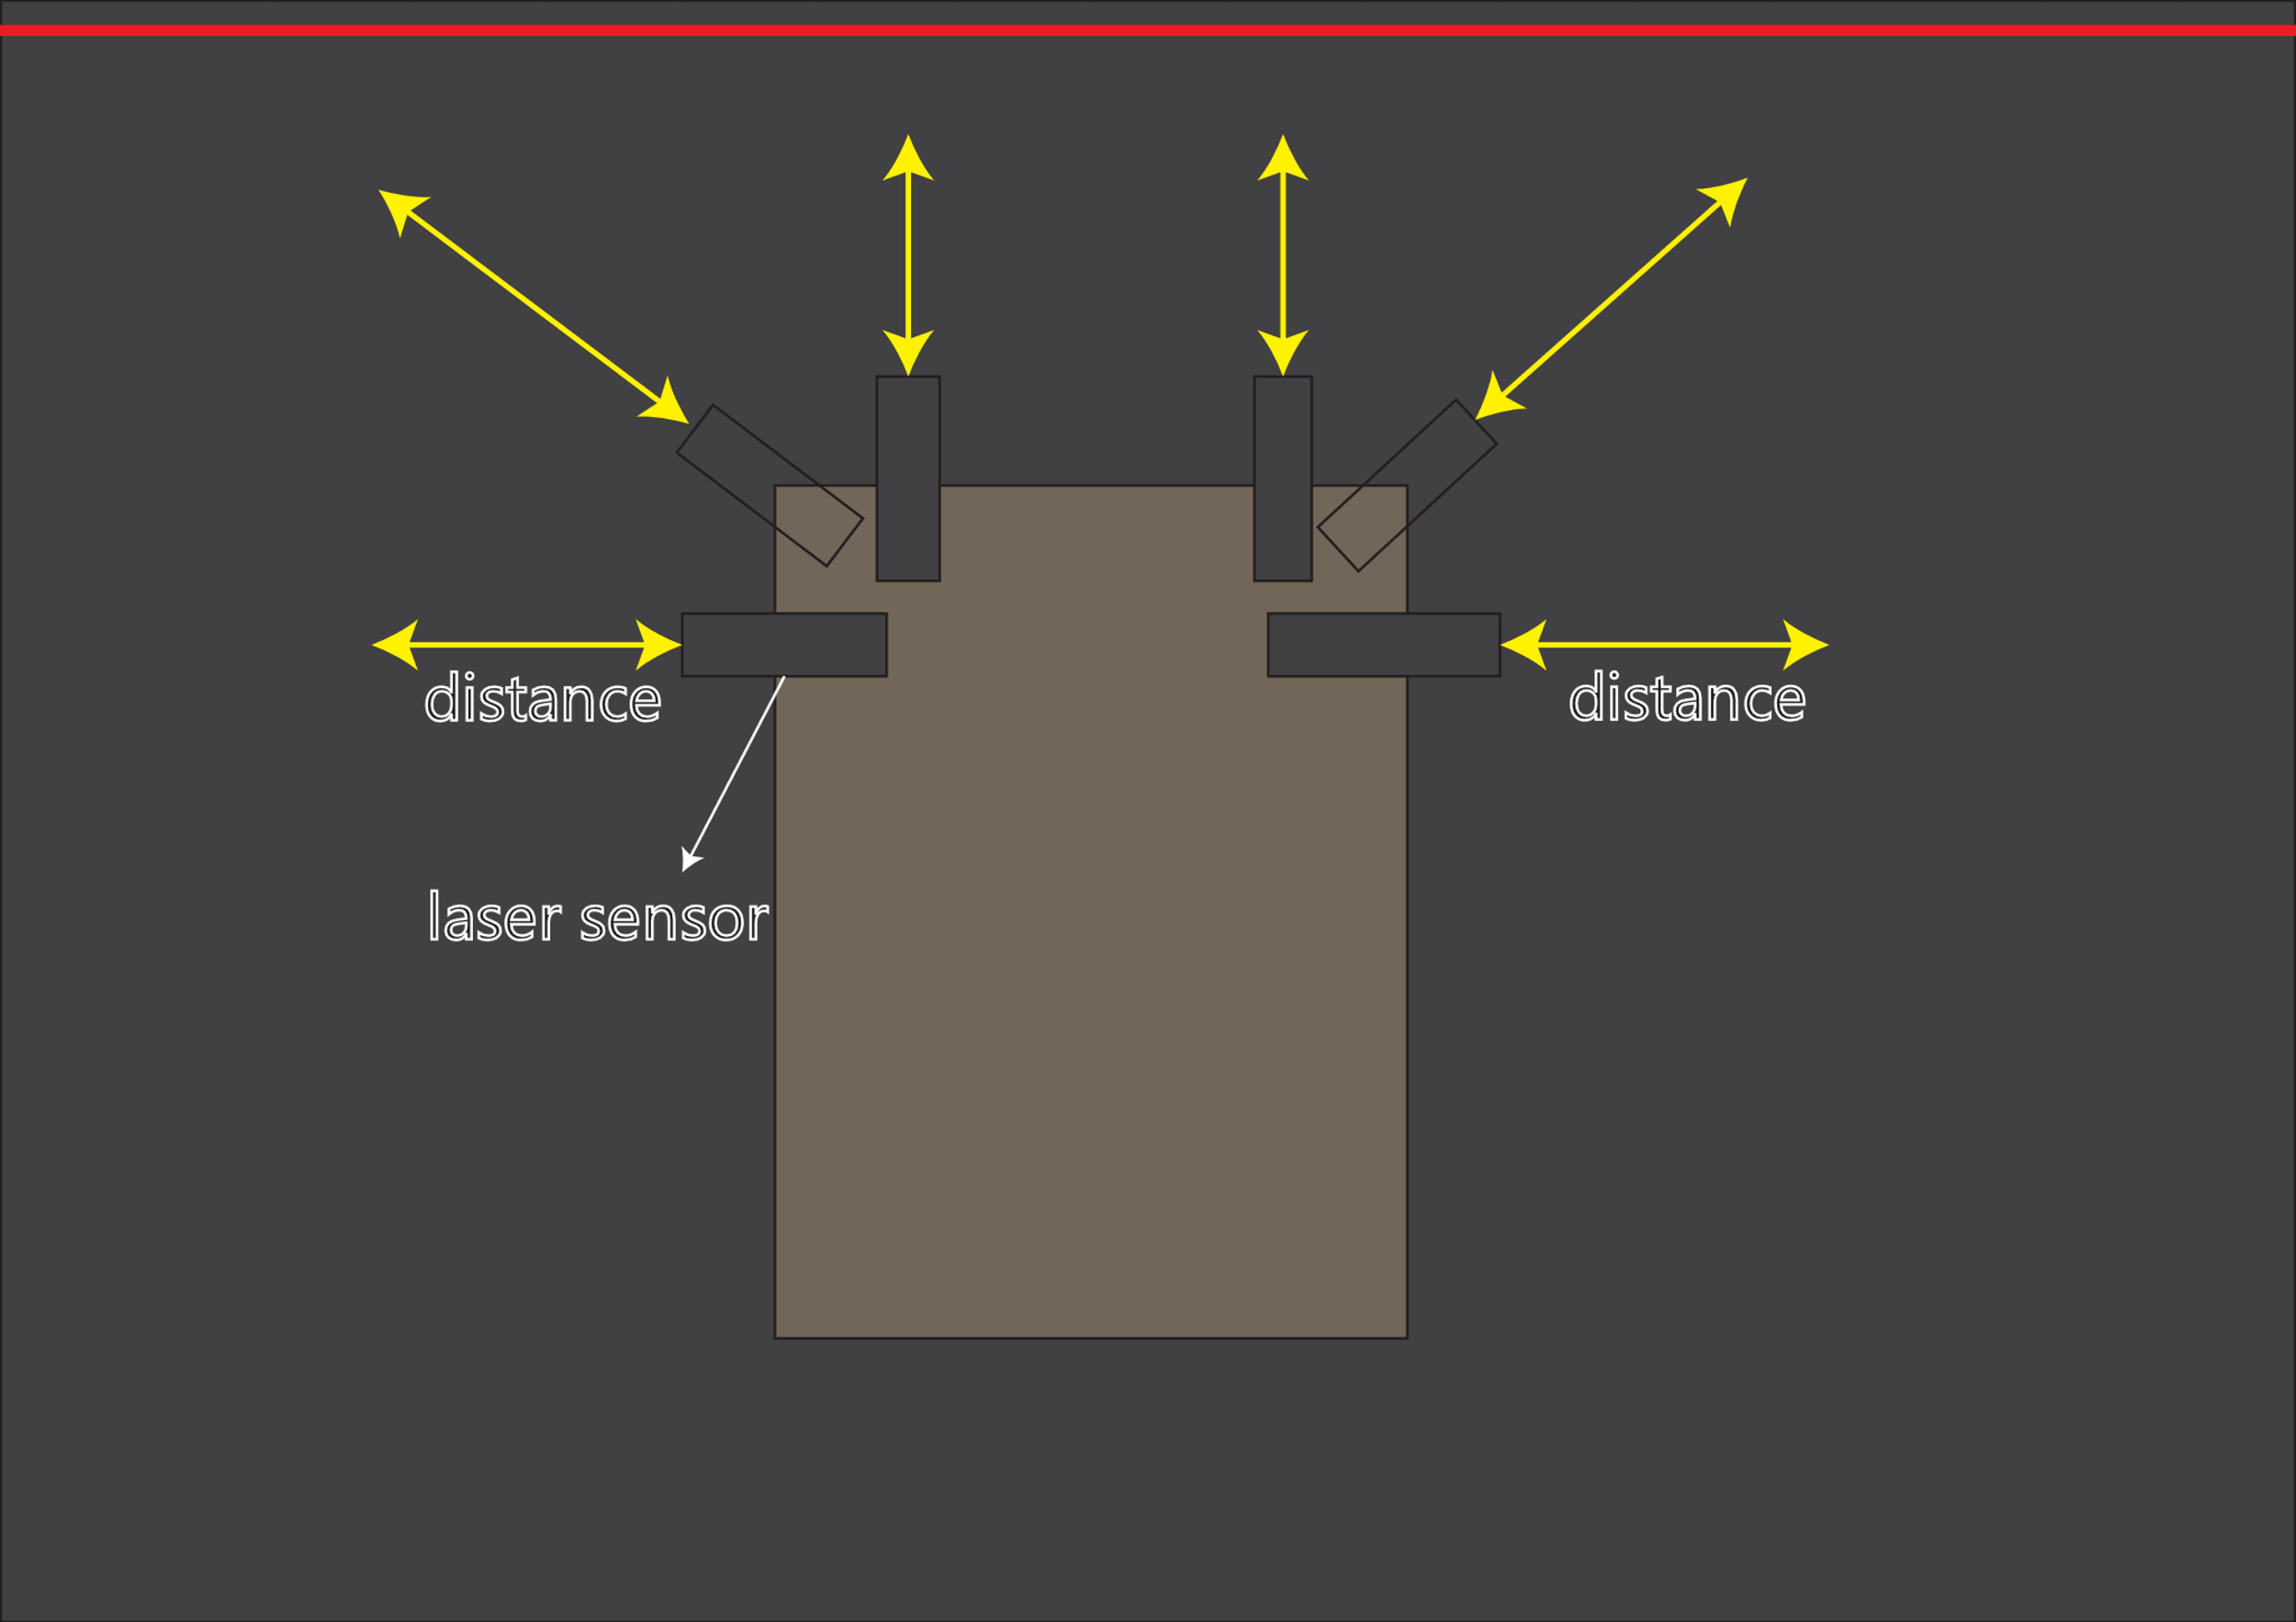

*Sensor placement*

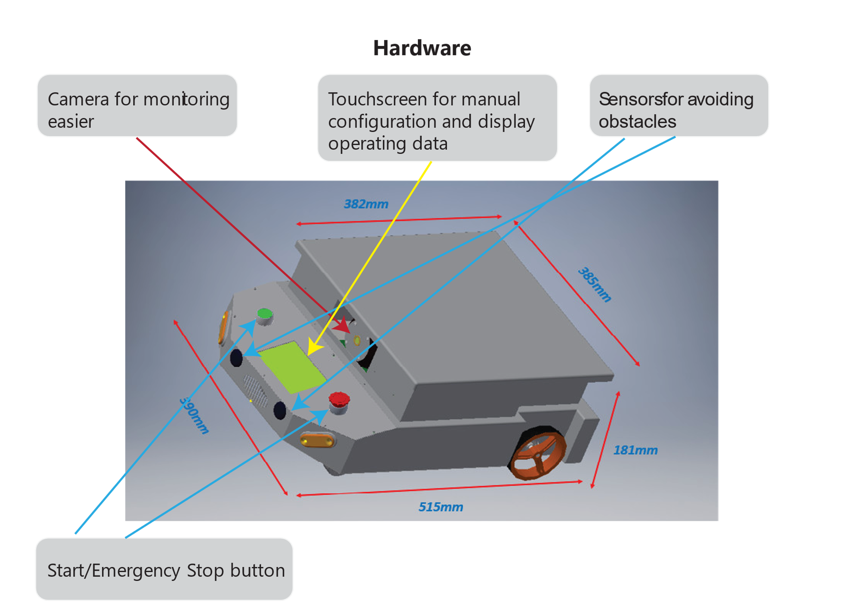

*3D demo design*

### **3.1.2. RFID**

Definition:

Radio Frequency Identification (RFID) is a type of passive wireless technology that allows for tracking or matching of an item or individual.

The system has two basic parts: tags and readers. The reader gives off radio waves and gets signals back from the RFID tag, while the tag uses radio waves to communicate its identity and other information.

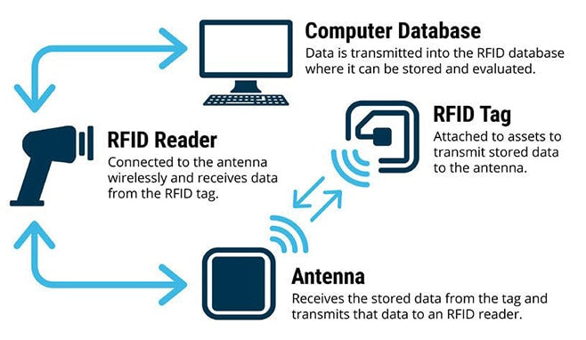

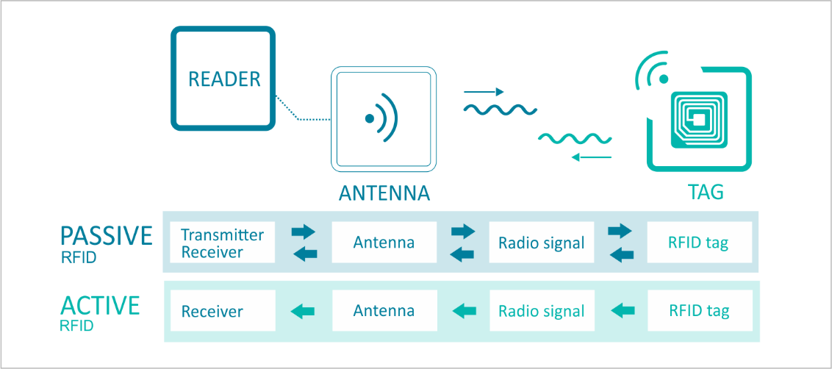

### **3.1.3. Bluetooth Low Energy**

Definition:

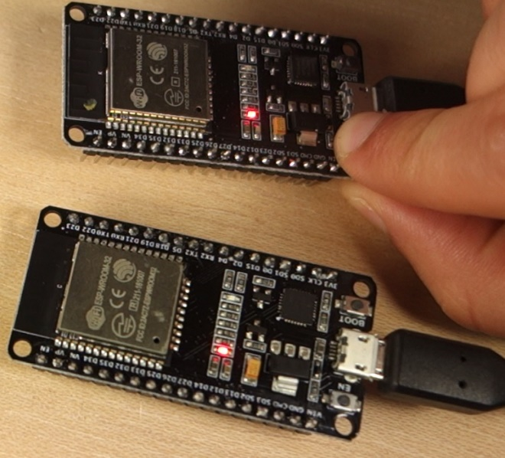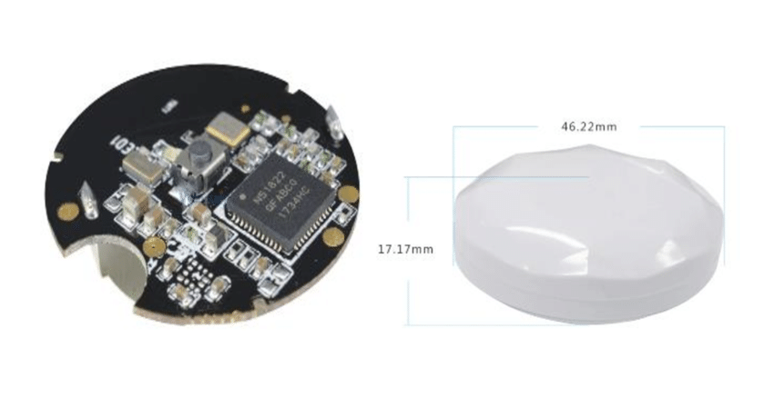 BLE stands for Bluetooth Low Energy. It is a wireless communication protocol which operates over 2.4 GHz frequency band. Bluetooth version 3 and below are called as "Bluetooth Classic" whereas Bluetooth 4.0 and above are classified as BLE (or Bluetooth Smart). The range of a BLE device is up to 400m( for BLE 5.0) and up to 100m(for BLE 4.0). Power consumption also varies widely. It depends on the implementation of the application, the different BLE parameters, and the chip-set used. The peak current consumption of a BLE chip-set during radio transmission is typically under 15 mA.

*Some typical beacon boards (right is ESP32 module)*

Communicate options in BLE:

There are 3 main communication options when it comes to BLE namely "point-to-point communication(1:1)" which is a connection oriented communication, "Data broadcast( 1 to many)" which is a connection-less oriented communication and the final type "BLE Mesh (many to many)" which is also an connection-less oriented communication.

*Point-to-point(1:1):*

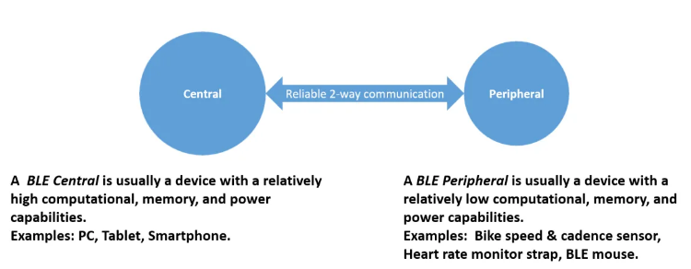

*Data broadcast:*

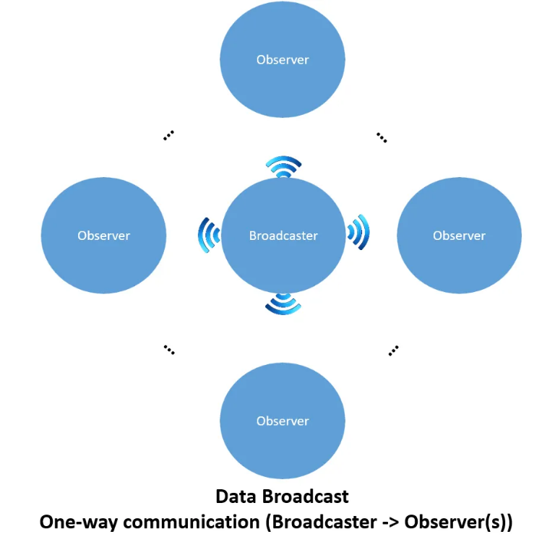

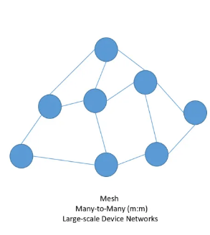*BLE Mesh:*

**Key terms and concepts**

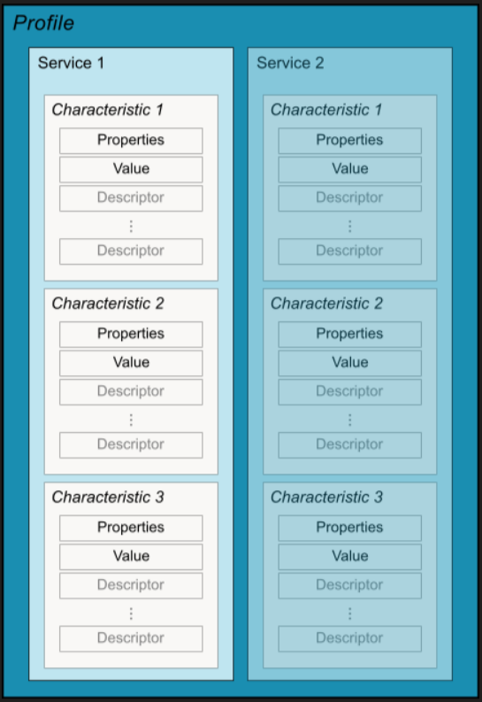

The following is a summary of key BLE terms and concepts:

**Generic Attribute Profile (GATT)**

The GATT profile is a general specification for sending and receiving short pieces of data known as "attributes" over a BLE link. All current BLE application profiles are based on GATT. Review the [Android BluetoothLeGatt sample](https://github.com/android/connectivity-samples/tree/master/BluetoothLeGatt) on GitHub to learn more.

**Profiles**

The **Bluetooth SIG** defines many [profiles](https://www.bluetooth.org/en-us/specification/adopted-specifications) for BLE devices. A profile is a specification for how a device works in a particular application. Note that a device can implement more than one profile. For example, a device could contain a heart rate monitor and a battery level detector.

**Attribute Protocol (ATT)**

GATT is built on top of the Attribute Protocol (ATT). This is also referred to as GATT/ATT. ATT is optimized to run on BLE devices. To this end, it uses as few bytes as possible. Each attribute is uniquely identified by a Universally Unique Identifier (UUID), which is a standardized 128-bit format for a string ID used to uniquely identify information. The *attributes* transported by ATT are formatted as *characteristics* and *services*.

**Characteristic**

A characteristic contains a single value and 0-n descriptors that describe the characteristic's value. A characteristic can be thought of as a type, analogous to a class.

**Descriptor**

Descriptors are defined attributes that describe a characteristic value. For example, a descriptor might specify a human-readable description, an acceptable range for a characteristic's value, or a unit of measure that is specific to a characteristic's value.

**Service**

A service is a collection of characteristics. For example, you could have a service called "Heart Rate Monitor" that includes characteristics such as "heart rate measurement." You can find a list of existing GATT-based profiles and services on [bluetooth.org](https://www.bluetooth.org/en-us/specification/adopted-specifications).

### **3.1.4. Laser distance sensor**

Definition:

[Laser distance sensors](https://sensorpartners.com/en/producten/laser/afstandslasers/) measure distances and allow it to take measurements at great distances. These distance sensors work on the basis of the Time-Of-Flight (ToF) principle, which means that the sensor emits a laser beam and receives the reflection from it. The time that elapses between sending and receiving the laser light ensures that the laser distance sensor can internally determine the distance. The distance over which the measurements can be taken differs per series.

VL53L0X sensor:

The VL53L0X is a Time-of-Flight (ToF) laser-ranging module housed in the smallest package on the market today, providing accurate distance measurement whatever the target reflectances unlike conventional technologies. It can measure absolute distances up to 2m, setting a new benchmark in ranging performance levels, opening the door to various new applications.

The VL53L0X integrates a leading-edge SPAD array (Single Photon Avalanche Diodes) and embeds ST’s second generation FlightSense™ patented technology.

The VL53L0X’s 940 nm VCSEL emitter (Vertical Cavity Surface-Emitting Laser), is totally invisible to the human eye, coupled with internal physical infrared filters, it enables longer ranging distance, higher immunity to ambient light, and better robustness to cover glass optical crosstalk.

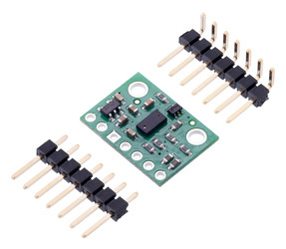

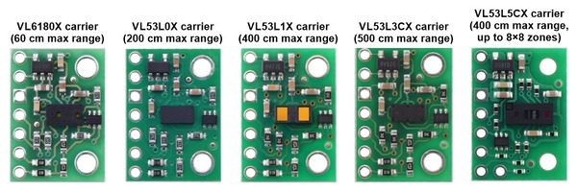

*VL53L0X and some ToF sensors*

## **3.2. Software**

### **3.2.1. User Interface for Operator**

### **3.2.2. User Interface for Manager/Admin/Developer**

# **4. Operations explanation**

## **4.1. Localizing method**

The method is used to determine where the robot is located with respect to its environment. Localization is one of the most fundamental competencies required by an autonomous robot as the knowledge of the robot's own location is an essential precursor to making decisions about future actions.

**Method description:**

**- Identify position by RFID card:**

- AGV moves to position where there is a RFID card

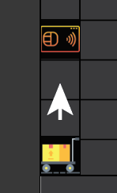

- AGV reads data from the card which includes information about coordinate of the card via integrated RFID reader

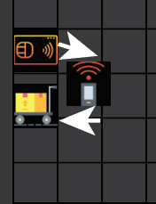

- AGV compares previous position with the new one and updates change to current map in database

- AGV gets signal strength index from nearby BLE beacons to get the relatively current area where it is in (red circle is cover range of each beacon)

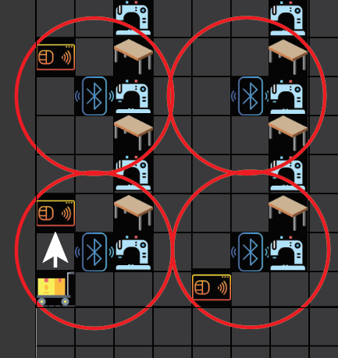

**- Identify relative position by RSSI value from BLE beacon:**

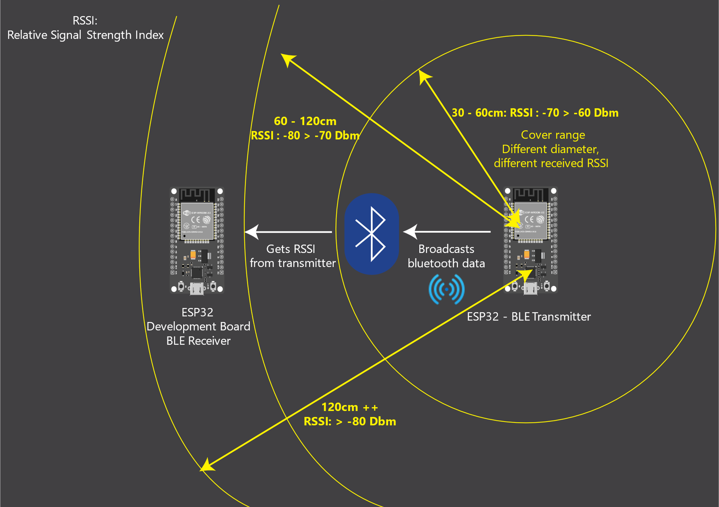

*Simple explanation about positioning relatively using RSSI value from BLE beacon*

## **4.2. Mapping method**

The method is used to construct the map where the AGV is in and what included as obstacles, other AGVs, BLE stations/beacons, RFID cards to help AGV to be able to localize its position in this map.

**Method description:**

**Map structure:**

- A blank map is created with input parameters of working area (floor dimension): Length and width. The map is associated with coordinate system with starting point (0,0).

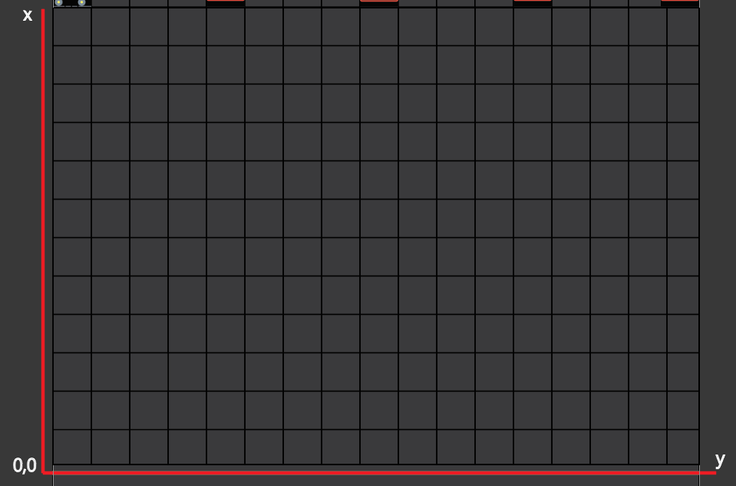

- Objects are added to map with corresponding colours:

+ Green represents for AGV

+ Blue represents for BLE beacon

+ Yellow represents for RFID card

+ Red represents for obstacle

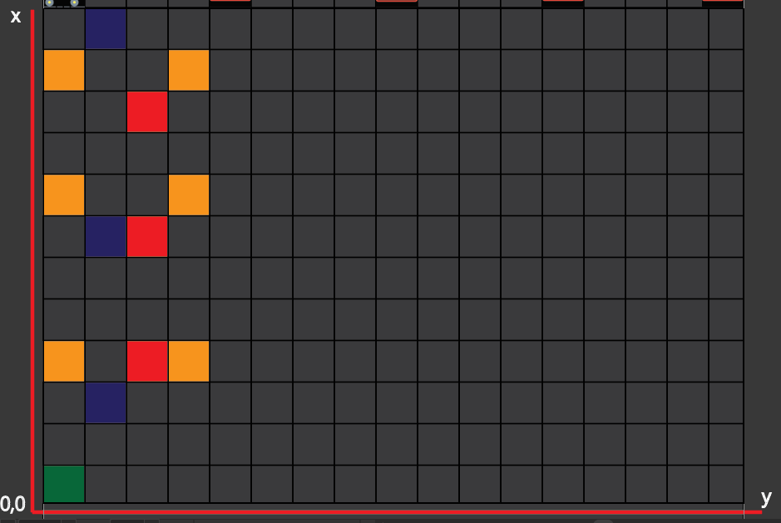

The colours are stored in database with corresponding values

The map is updated with AGV position, obstacle position synchronously with new RFID scan or signal receiving from beacons.

## **4.3. Guiding method**

The method receives data from localizing and mapping method, then calculates to make final decision which route should follow and moving actions.

Method description:

**Available guiding decisions:**

+ Move (forward, backward, right, left)

+ Stop

+ Play warning sound

+ Avoid obstacle (by sequence of moves)

**Available combinations of guiding decisions:**

**- Keep robot goes straight**

**Case 1: Lobby is wide enough**

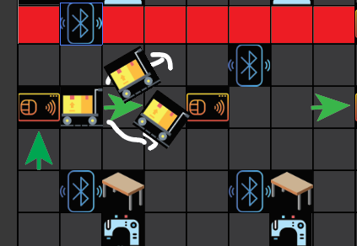 **- Moving not straight is accepted**

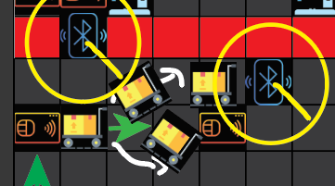 **Laser sensors and signal from nearby beacons allows AGV not comes too close to the wall (red point)**

**Case 2: Lobby is just fit to AGV size**

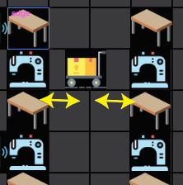

**Laser sensors help AGV keeps distance to both sides of the lobby**

**- Avoid obstacle if there is an available alternative path**

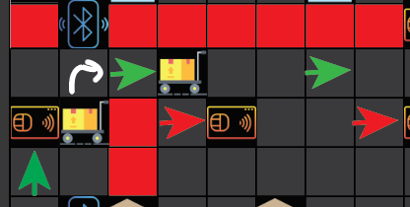

**- Back to nearest route when out of route by some factor**

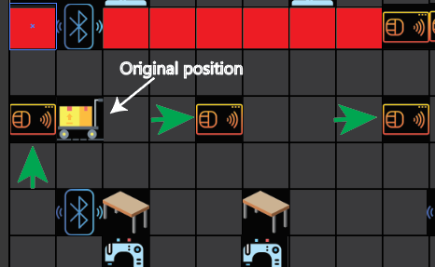

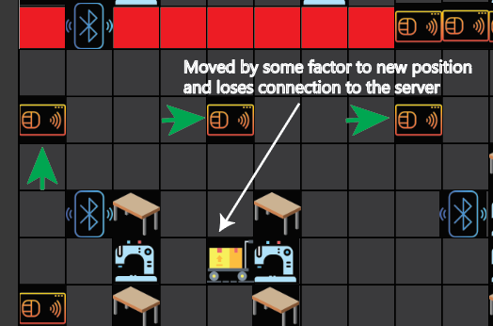

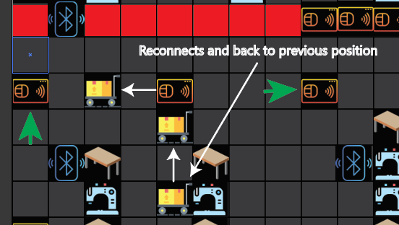

## **4.4. Manual mode**

The mode that AGV will be directly controlled by admin/developer/admin from the server by a web app

## **4.5. Automated mode**

The mode that AGV will automatedly move and make its own decisions on the way to transport the packages to destination.

Description:

- AGV gets the delivery request from the server/directly on integrated display by operator

- If the delivery is available, AGV calculates path to destination

- When the calculation is completed, AGV in turn executes below steps, repeatedly until reaches the final destination:

Localize > Update Map >Navigate (Making moving decision)

**Mode description:**

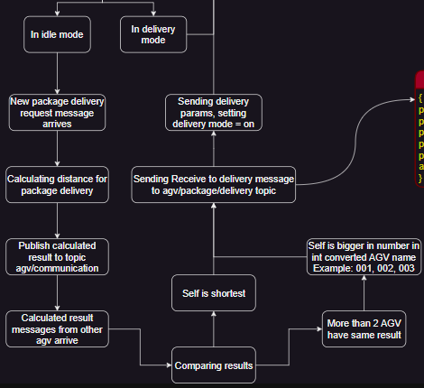 **Get delivery request from the server:**

**Get delivery request directly from integrated display by operator:**

**Available problem scenarios:**

**Case 1: From starting point, move to point A to pick up the package, then transport to point B and return to starting point.**

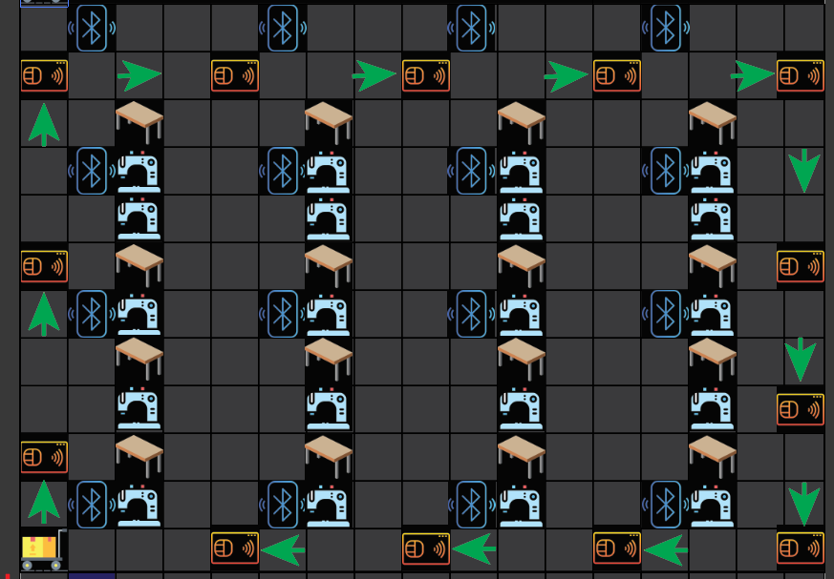

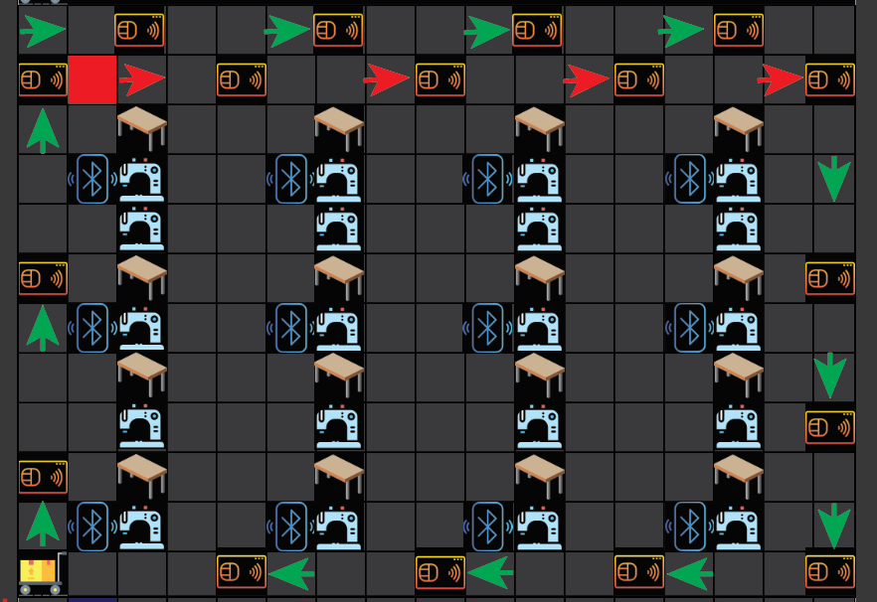**Case 2: From starting point, move to point A to pick up the package, then transport to point B, but on the way there is an obstacle, AGV switches to the alternative path, when delivery completes, return to starting point.**

**Case 3: From starting point, move to point A to pick up the package, then transport to point B but on the way there is an obstacle, there is no alternative route too, so AGV stops and all system stops working until the obstacle is removed.** 